Index

About Almighty Consulting Services

Introduction to HMS

Hospital Departments

Physician Management

Patient Management

Patient Appointment Management

Patient Treatments

Patient Prescriptions

Medicine & Services

Referring Physician

Configure Hospital Flow and Data

User Roles

Introduction to HMS
A hospital Management system (HMS) is an element of health informatics that focuses mainly on the administrational needs of hospitals. In many implementations, an HMS is a comprehensive, integrated information system designed to manage all the aspects of a hospital's operation, such as medical, administrative, financial, and legal issues and the corresponding processing of services. Hospital Management system is also known as hospital information software (HIS).
Hospital Management systems provide a common source of information about a patient's health history. The system has to keep data in a secure place and controls who can reach the data in certain circumstances. These systems enhance the ability of health care professionals to coordinate care by providing a patient's health information and visit history at the place and time that it is needed. Patient's laboratory test information also includes visual results such as X-ray, which may be reachable by professionals. HMS provide internal and external communication among health care providers. Portable devices such as smartphones and tablet computers may be used at the bedside.
Based on our experience and technical knowledge we developed this Hospital Management Vertical. Using this modules users can manage their HMS related flows and requirements. To make it more easy and simple we have divided HMS in multiple parts so users can use whichever flows are useful for them based on need.

What are the benefits of a Hospital Information System?
A good HIS offers numerous benefits to a hospital including but not limited to the delivery of quality patient care and better financial management. An effective HMS also delivers benefits such as:
- Enhances information integrity
- Reduces transcription errors
- Reduces duplication of information entries
- Optimizes report turnaround times

Potential Modules of hospital management systems (20+ Modules):
- HMS Online Appointment
- Facility Management System
- Documents Preview
- Laboratory Imaging
- Certificate Management System
- Hospital Patient Portal Management
- Hospital Patient Document Management
- ACS Product Barcode Generator
- Hospitalization
- Hospital Next Patient Waiting Screen
- Hospital Vaccination Management
- Patient Barcode in Hospital Management
- Hospital Laboratory Management
- Hospital Doctor Commission Management
- Hospital Pharmacy Management
- Medical Representative
- ACS HMS Dashboards
- Patient Insurance Management System
- Hospital Management System
- HMS Operation Theater Booking
- Hospital Management System for Gynecologist
- Physiotherapy Hospital Management System
- Hospital SMS Notification

Hospital Departments
In every Hospital there can be multiple departments for patient treatment like Cardiology, Gynec, Physiotherapy and many more. To Manage different departments efficiently we need to define and separate patients based on it.
We have Designed system to show Department related patients only to Physicians & Receptionist so if you have big hospital you do not need to worry about Patient detail sharing to other department Users.
E.g if Dr. is Gynec we can allow access to him related to gynec and that dr will see Patient related to that department only. Same for Receptionist also.
Go to Employees >> Departments menu and define all departments.
TIP: Normal Employee Departments can be also defined here. Like Nurse, Security Accounting. Those have nothing to-do with HMS so to distinguish such department and
avoid selection of them on related record untick “Patient Department”
Once All Departments are defined we can assign departments on related users.
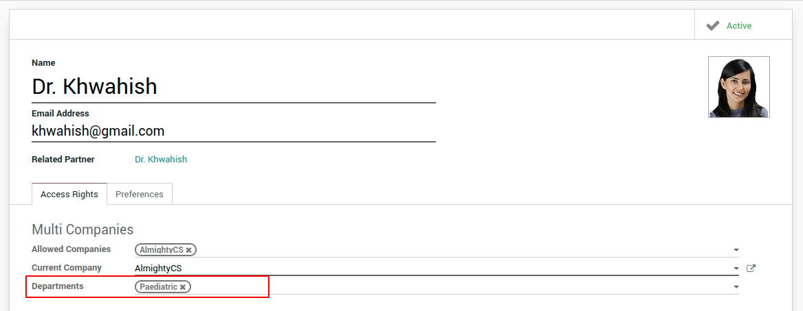

Physician/Doctor Management
To manage Physicians in system you can go to Doctor Menu and Create/Edit records. You can define all related information of doctor here, Like Departments, Speciality, Signature, Personal details (address, phone no and related details). For every Physician system will create User automatically.
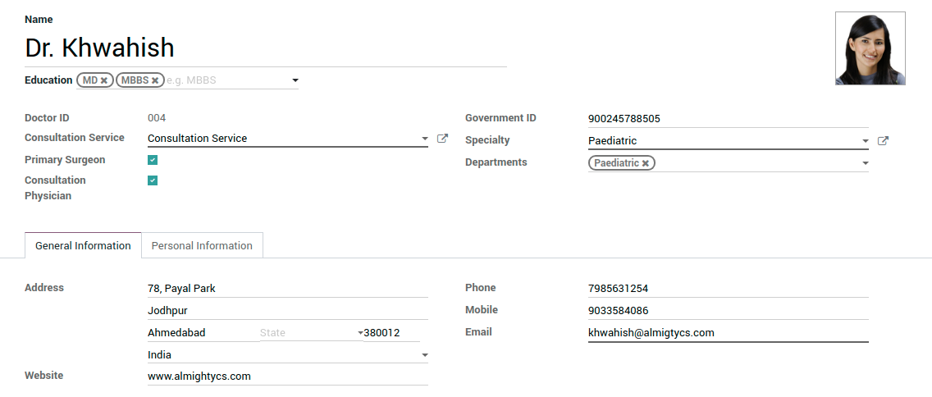
TIP: Always Create Doctore from here and after that if you want to change access you can go to settings >> users menu and edit related user access.
In Personal Information tab Doctor Signature can be Uploaded which can be printed in some documents.

Patient Management
To manage the Patients go to Patients menu and Create or Edit the record. You can manage the basic information like address, mobile, Blood Group etc.. about the patient in the General Information.

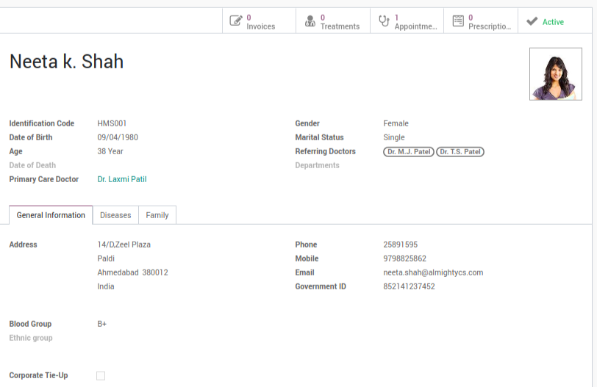
In the Diseases tab, you can manage and refer the past disease of the patient with the respective date and the doctor under which the treatment is done. You can also check the Family disease history to know the hereditary diseases and genetic risks for further treatments.
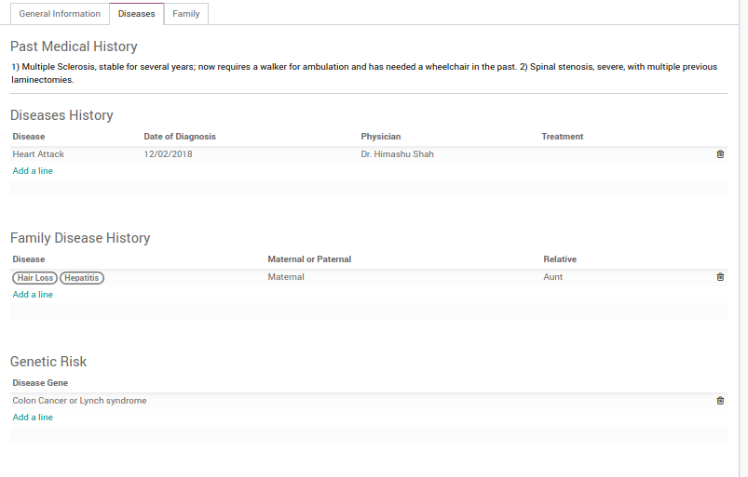
Generic Risk
To contact the family for patient in some emergencies, members can be added in the Family tab.
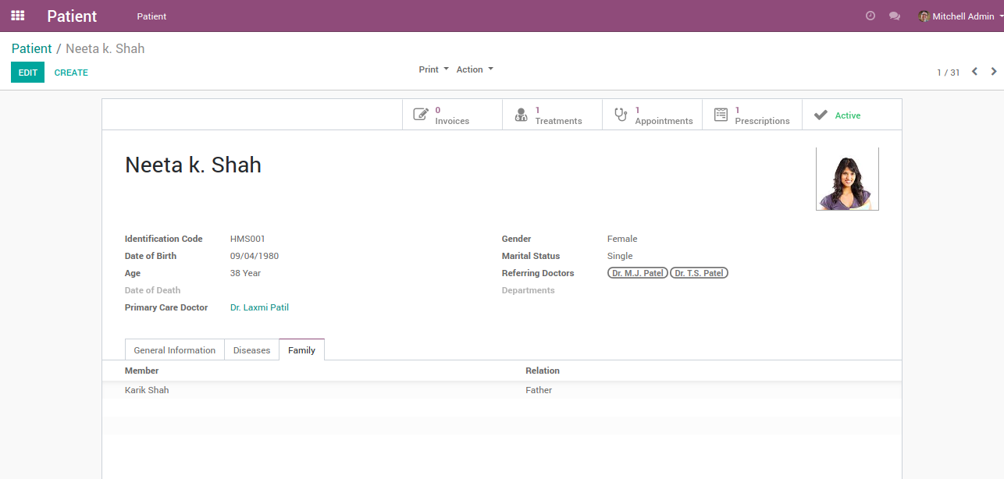
The patient related Invoices, Prescriptions, Treatments and Appointments can be seen through respective buttons in the patient form.
☺️TIP: Once the patient discontinues, you can also deactivate the record. If patient Neeta dies for some unexpected reason, you can deactivate the patient to reduce the database load. You can insert the Date of Death then.

Patient Appointment Management
Patient’s Appointments can be managed easily by using system based on rules of Hospital/Clinic. The receptionist can create Patient appointments by entering related information like Patient name, Department, Date…
Normally Receptionist will create Appointments. There can be many options to take appointments
- Patient can call and book Appointment
- The patient can walk into the hospital and book it.
- Online Appointment can be booked from the website

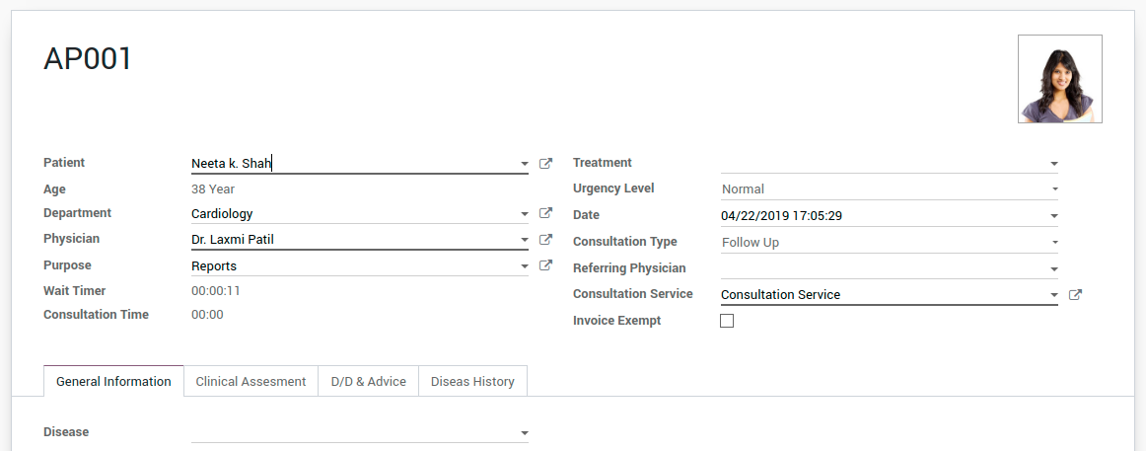
TIP: Default Consultation and Follow Up services can be configured in a company setting. If Dr. has Diff Consultation service (Consultation Charges) it can be defined on dr and when creating an Appointment with that dr it will be as configured on Doctor.

There are some states of appointment to have a clear view.
- When Appointment is created it will be in Draft state.
- Once Proper data entered Appointment will be confirmed (New unique appointment no will be assigned.)
- When Patient Arrives in Hospital/Clinic for appointment receptionist will click on waiting. (on System will calculate waiting time for each appointment)
- Dr will check the queue of waiting appointment list and call them for consultation
- Once an appointment is in consultation Dr. can Diagnose patient.
  - Based on the condition of patient Dr. Can prescribe Medicines
  - Refer to other Dr.
  - Ask for Lab reports.
  - Hospitalize the patient.
- Once Consultation is done Dr will mark it as done and complete the process.
- After Consultation it’s time to Create Appointment invoice.

TIP: Default Invoice will be created after the consultation is done. Based on requirement this can be changed also by changing a setting in the company. The invoice can be mandatory to confirm an appointment or you can allow user to create invoice anytime during the consultation.

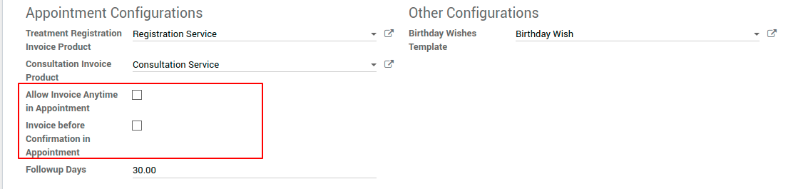
Once an appointment is confirmed basic data can be entered by jr. Dr or Nurse to make the consultation process fast and easy for Dr.
- Weight
- Temp
- RR
- BP
- HR
- Chief Complaints
- History of Present Illness
- Past History

✰ Patient Treatments
Treatments can be managed for the patient in case if patient treatment is going on for a particular disease. (Where Patient need to have multiple visits/Appointments to the clinic/Hospital). For Each patient we do not create Treatments we create it when patient will need multiple visits to cure disease.
Treatment can be created with data as shown in the image. The only patient is required field to do it fast. Once treatment is created it will assign a unique number so it can be searched and referred easily.

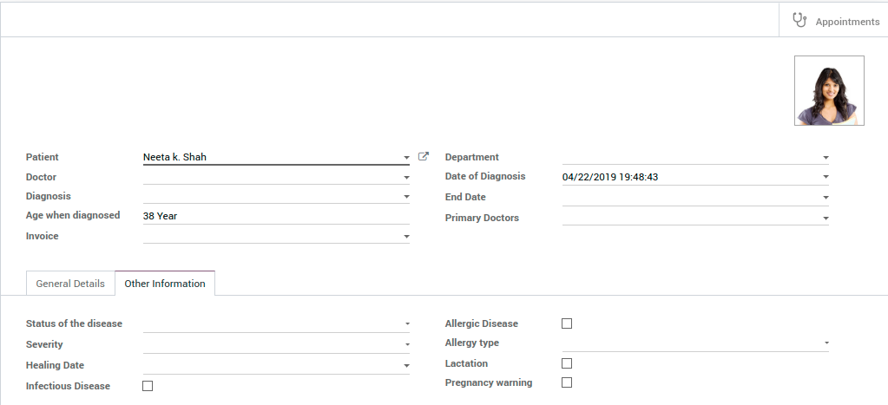
Using smart button on right top corner you can see all related appointments. Invoice can be created for Treatment creation also. (if Hospital charges patient for file creation it is not required to create invoice.)

☺️TIP: Create Appointments from treatment if it is for particular treatment because it will by default set treatment, patient name and doctor and you can save time.

✰ Patient Prescriptions
After completing consultation Dr. will write a prescription based on the diagnosis.
When Dr create Prescription for Appointment it will set some data by default like patient, Dr. and Appointment. Once Prescription is confirmed it will assign unique number so it can be searched and referred easily.
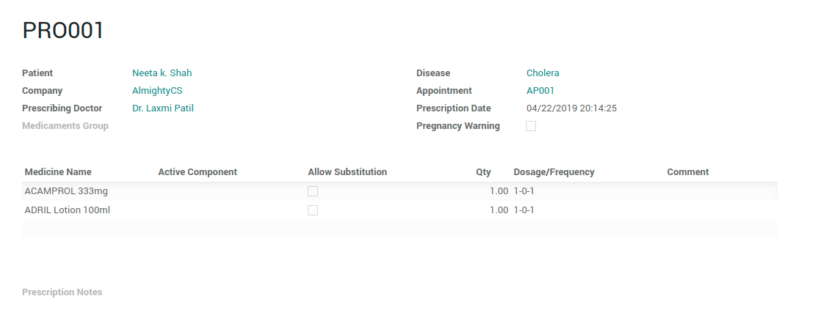
Prescriptions can be sent by mail also to patient if they want. If you are managing in house pharmacy, pharmacy user will directly see the prescription and can give medicine. If there is no in house Pharmacy Prescription print can be given to patient so they can show that to Pharmacist and get medicines

☺️TIP: Medicament Group can be created for particular disease with predefined medicine lists . When you select Medicament Group it will automatically add related medicines. This can save the Precious time of Doctor.

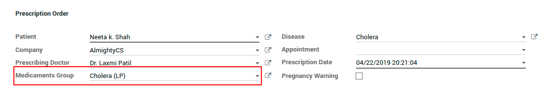
Medicine & Services
There are separate menus for setting up Medicine and services which hospital Offers.
In medicine configuration there are separate menus for setting up medicine data.
- Drug From: Drug forms type like tablet, syrup, injection...
- Active Components: Ingredient components of the medicine
- Drug Company: Drug Manufacturing Company
- Dosage: Default Dosage for use
- Flavor: Flavor of medicine.
- Route: Route to take medicine like from mouth or nose...
- Group: Medicament groups for fast prescriptions.

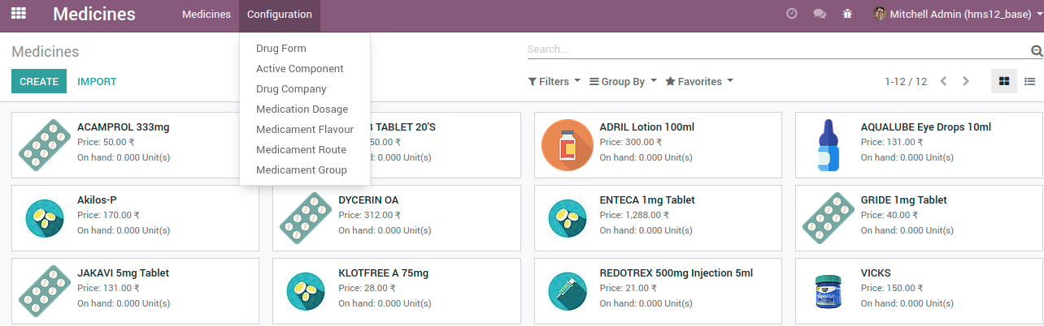
Once all properties are created it can be used in medicine setup.
☺️TIP: Proper Medicine creation and maintaining data is required for easy prescription by a doctor. And medicine property are not unique by name so make sure that same property do not exist in the system to avoid duplication of useless data.

✰ Referring Physician
A Referring Physician is one who sends a patient to a specialist for more information or treatment.
Many times there is situation that a doctor diagnosis the patient and he finds that in this case a surgery is needed so he refers a special Surgeon for further treatment. So such physicians can be configured from menu Referring Physician and you can select them in the Appointments to just mention it.
☺️TIP: These Physicians are identified from other physicians with a boolean Is Referring Physician.
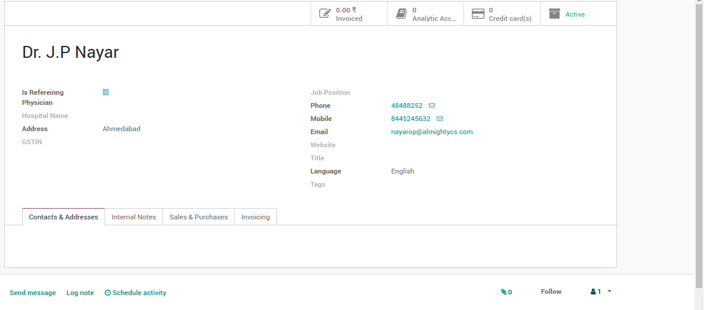
S

Configure Hospital Flow and Data
As first step of setup set Hospital Details, Go to Settings >> Users & Companies >> Companies and set the information of your Hospital Name, Address, email, website, TIN/GSTIN, Currency and logo.
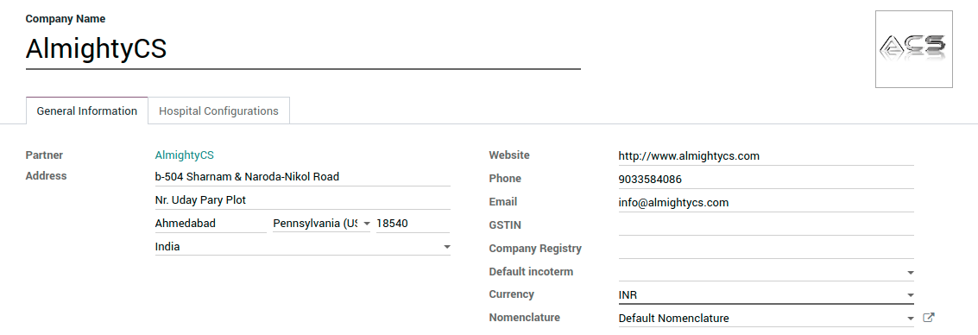
Once Updated Hospital details configured other options in Hospital Configurations Tab. All Options are self-explanatory by name.

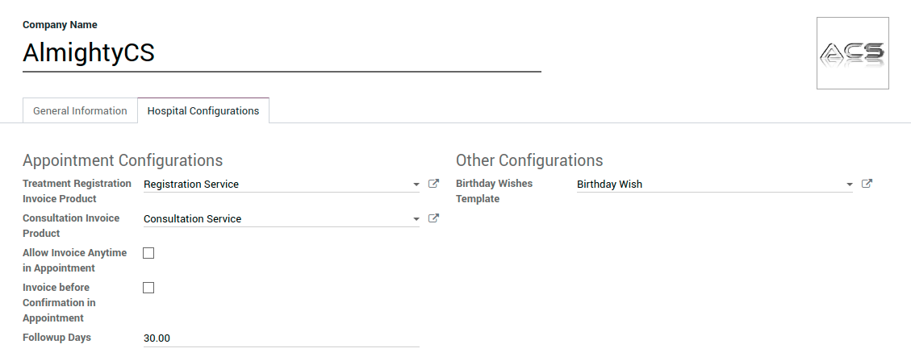
User Roles
Same as default odoo user access management HMS access can be given to users. There are six predefined user roles in our HMS.
Based on user roles in the hospital, related access can be given. Lowest access is User and Highest access is Manager.
TIP: To manager special menu ”HMS” access will be there. In HMS menu user will able to see all records from single place and they will not need to move from one menu to another to access records.

